TP MODUL 12

Nama: Zhafir Zaidan Avail

NIM: 2311104059

Hasil run:

Sebelum input

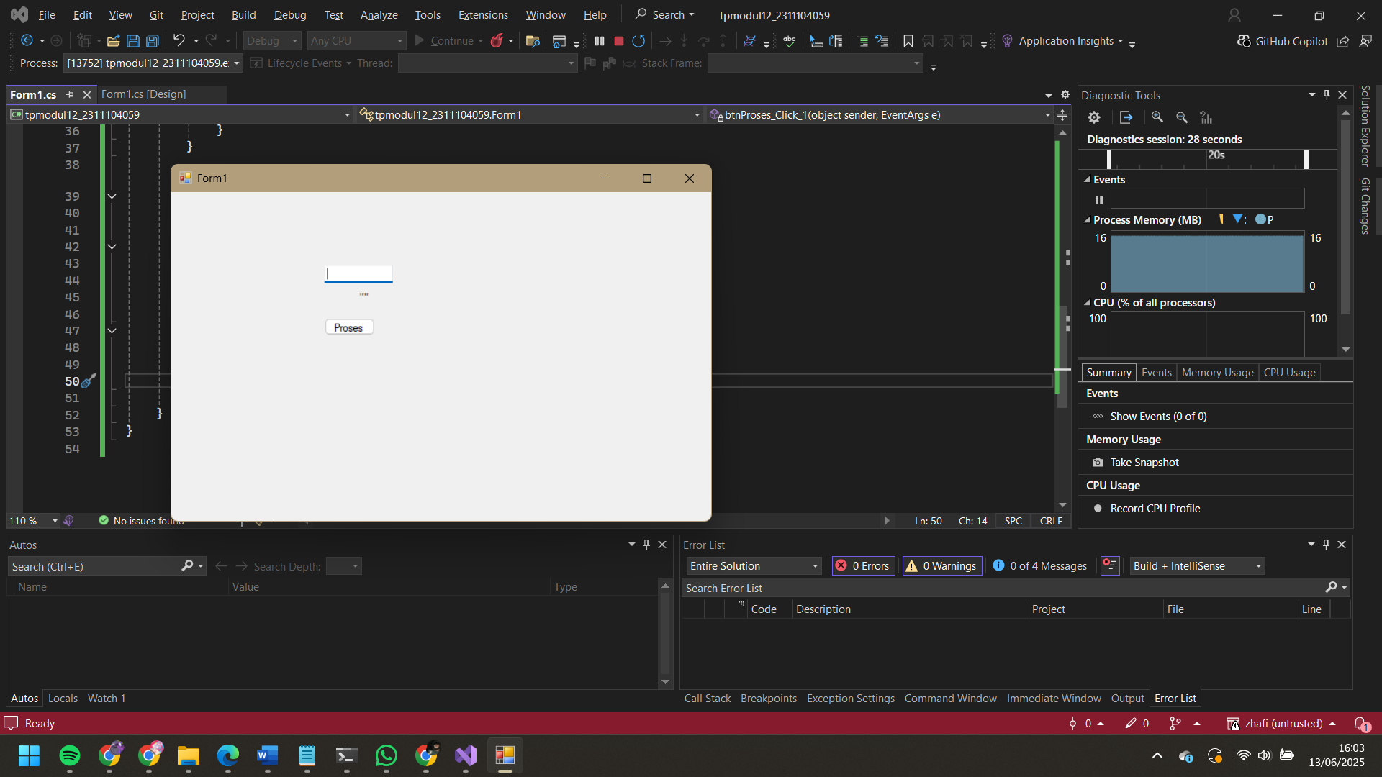

Setelah input

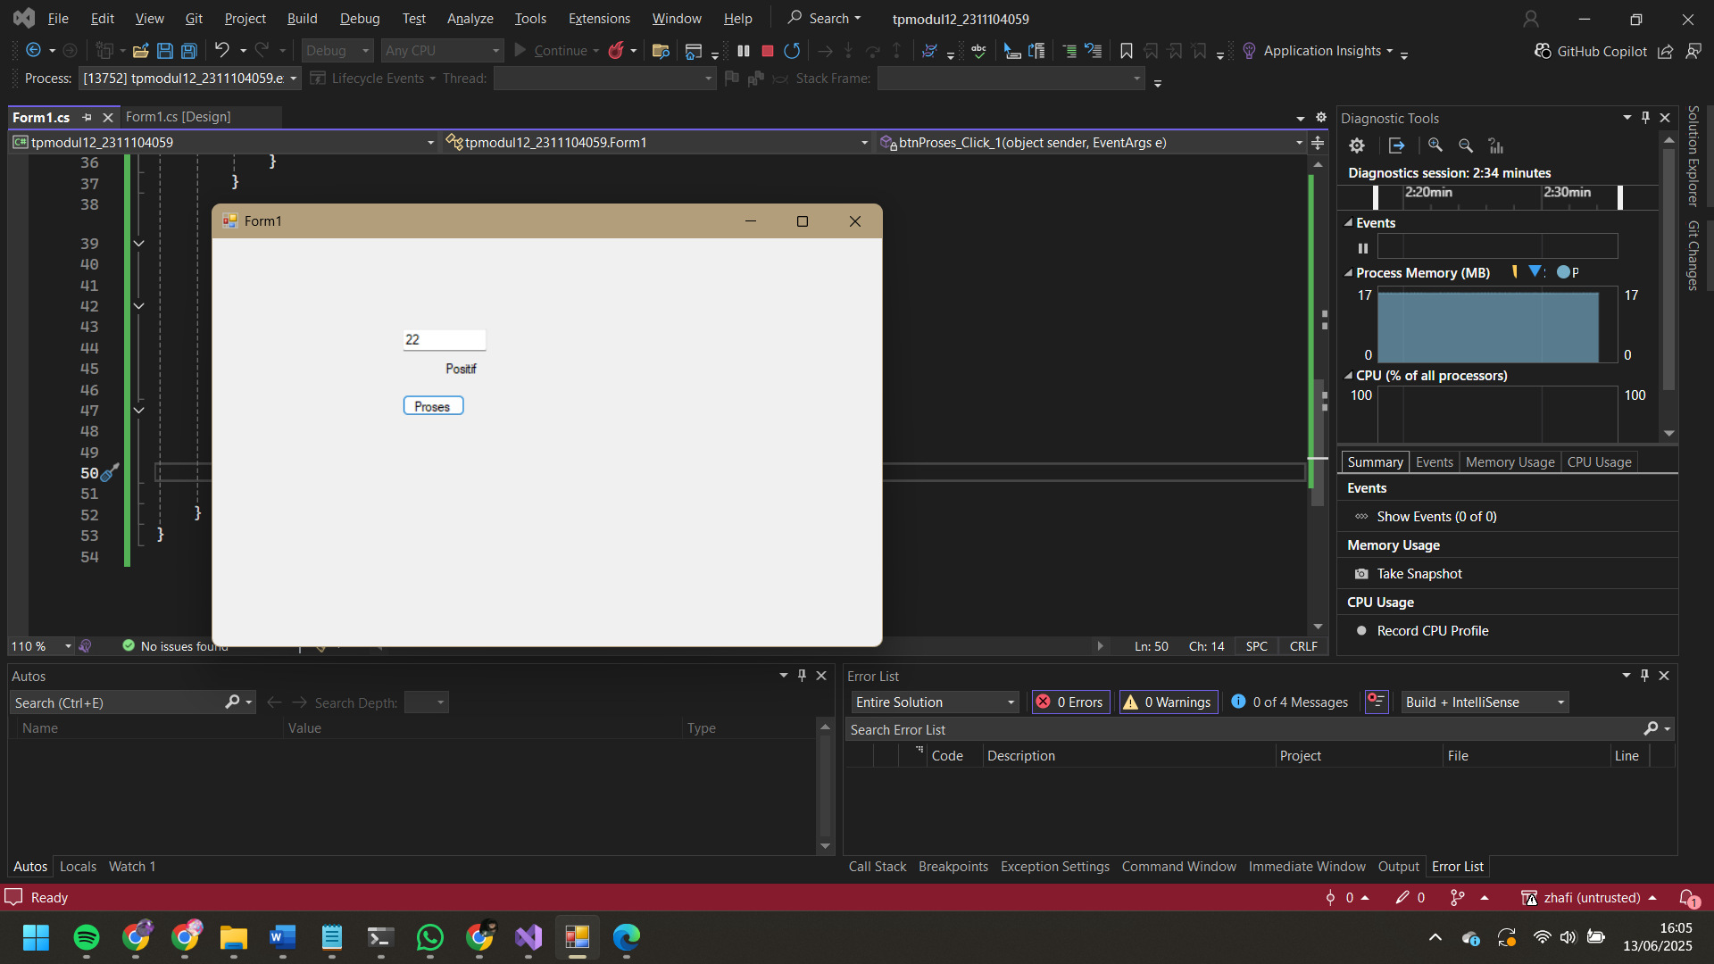

Fungsi CariTandaBilangan:

private string CariTandaBilangan(int a)

{

if (a < 0)

return "Negatif";

else if (a > 0)

return "Positif";

else

return "Nol";

}

Logika Saat Tombol Ditekan:

private void btnProses_Click(object sender, EventArgs e)

{

int inputAngka;

if (int.TryParse(txtInput.Text, out inputAngka))

{

string hasil = CariTandaBilangan(inputAngka);

lblHasil.Text = hasil;

}

else

{

lblHasil.Text = "Input tidak valid!";

}

}

Menambahkan Unit Testing:

[TestClass]

public class UnitTest1

{

[TestMethod]

public void TestNegatif()

{

var form = new Form1();

Assert.AreEqual("Negatif", form.CariTandaBilangan(-5));

}

[TestMethod]

public void TestNol()

{

var form = new Form1();

Assert.AreEqual("Nol", form.CariTandaBilangan(0));

}

[TestMethod]

public void TestPositif()

{

var form = new Form1();

Assert.AreEqual("Positif", form.CariTandaBilangan(10));

}

}